**COMPREHENSIVE VAPT ANALYSIS ON NETWORK INFRASTRUCTURE**

The domain of the Project

Cybersecurity - Network and Web Application Security

Under the guidance of

Mr. Nishchay Gaba (Penetration Tester)

By

Mr. Darshan Moradiya (B.Tech)

Period of the project

September 2024 to February 2025

SURE TRUST

PUTTAPARTHI, ANDHRA PRADESH

**DECLARATION**

The project titled **“*Comprehensive VAPT Analysis on Network Infrastructure*”** has been mentored by **Mr. Nishchay Gaba** and organized by SURE Trust from September 2024 to February 2025**.** This initiative aims to benefit educated unemployed rural youth by providing hands-on experience in industry-relevant projects, thereby enhancing employability.

I, **Mr. Darshan Moradiya,** hereby declare that I have solely worked on this project under the guidance of my mentor. This project has significantly enhanced my practical knowledge and skills in the domain.

### **Name** **Signature**

Mr. Darshan Moradiya



### Mr. Nishchay Gaba

### **Mentor** **Signature**

### **Seal & Signature**

Prof.Radhakumari Executive Director & Founder

SURE Trust

# ***Table of Contents***

***Table of Contents*** 2

**1.** **Document control** 3

**1.1** **Statement of confidential** 3

**2.** **Disclaimer** 4

**3.** **Introduction** 5

**3.1** **Objectives** 5

**3.2** **Scope of security assessment** 5

**3.3** **Limitations** 5

**4.** **Executive Summary** 6

**4.1** **Summary of findings** 6

**5.** **Scope of security assessment** 7

**6.** **Testing Approach** 8

**7.** **PUBLIC IP** 9

**8.** **Conclusion** 71

1. **Document control**
   1. **Statement of confidential**

This document contains sensitive information regarding the security posture of the assessed network. It is intended solely for the use of authorized personnel. Unauthorized access, disclosure, or distribution of this document is strictly prohibited. All recipients are required to maintain the confidentiality of the information contained herein.

1. **Disclaimer**

The information provided in this report is based on the findings from the assessment conducted on the specified date. The authors of this report make no representations or warranties regarding the accuracy, completeness, or reliability of the information contained herein. The organization shall not be liable for any damages arising from the use of this report or the information contained within it.

1. **Introduction**
   1. **Objectives**

The primary objective of this VAPT is to identify vulnerabilities within the network infrastructure that could be exploited by malicious actors. The assessment aims to provide actionable recommendations to enhance the security posture of the organization.

* 1. **Scope of security assessment**

The assessment encompasses the following:

1. All IP addresses and associated open ports identified during the scanning process.
2. Services running on the identified ports.
3. Vulnerabilities associated with the services and configurations.

|  |  |
| --- | --- |
| **DEVICES** | **TOTAL IPS** |
| **PUBLIC IP** | **31** |

Table 1 - Scop List

* 1. **Limitations**

The assessment depends on provided data, excluding physical security and social engineering. Time, scope, and dynamic network changes constrain findings. It may not detect all vulnerabilities, potentially including false positives or negatives, and is bound by legal and ethical guidelines.

1. **Executive Summary**
   1. **Summary of findings**

The security assessment report outlines several vulnerabilities in network infrastructure. Critical risks include an unsupported Windows 7 OS and the BlueKeep RDP vulnerability, both allowing potential remote code execution. High severity issues encompass default credentials on Telnet and FTP, RDP misconfigurations without Network Level Authentication, and open ports on web servers potentially leading to unauthorized access and data exposure. Medium risks involve outdated software (PHP, VNC), default SNMP community strings, and misconfigured SNMP settings, risking information leakage. Mitigation strategies include immediate system updates, changing default credentials, enforcing secure configurations, and restricting access to sensitive services to prevent exploitation.

1. **Scope of security assessment**

Each finding has been assigned a severity rating of CRITICAL, HIGH, MEDIUM, LOW. The rating is based on an assessment of the priority with which each finding should be viewed and the potential impact each has on the confidentiality, integrity, and availability of the Client's data.

|  |  |
| --- | --- |
| **Severity** | **Definition** |
| **Critical 9.0 - 10.0** | Vulnerabilities that score in the critical range usually have most of the following characteristics: • Exploitation of the vulnerability likely results in root-level compromise of servers or infrastructure devices. • Exploitation is usually straightforward, in the sense that the attacker does not need any special authentication credentials or knowledge about individual victims, and does not need to persuade a target user, for example via social engineering, into performing any special functions. • It is advised that you patch or upgrade as soon as possible, unless you have other mitigating measures in place |
| **High 7.0 - 8.9** | Vulnerabilities that score in the high range usually have some of the following characteristics: • The vulnerability is difficult to exploit. • Exploitation could result in elevated privileges. • Exploitation could result in a significant data loss or downtime |
| **Medium 4.0 - 6.9** | Vulnerabilities that score in the medium range usually have some of the following characteristics: • Vulnerabilities that require the attacker to manipulate individual victims via social engineering tactics. • Denial of service vulnerabilities that are difficult to set up. • Exploits that require an attacker to reside on the same local network as the victim. • Vulnerabilities where exploitation provides only very limited access. • Vulnerabilities that require user privileges for successful exploitation. |
| **Low 0.1 - 3.9** | Vulnerabilities in the low range typically have very little impact on an organization's business. Exploitation of such vulnerabilities usually requires local or physical system access. Vulnerabilities in third party code that are unreachable from Atlassian code may be downgraded to low severity. |

*Table 2. Risk Impact Definition*

1. **Testing Approach**

**Black Box Assessment** - A Black-box penetration test is a penetration testing service that aims to find & exploit vulnerabilities in a system as an outsider. The security expert is provided with no information about the target system prior to the testing except the target URL and access similar to an end-user. This means the tester has no access to source code (other than publicly available code), internal data, structure & design of the application before the testing.

1. **PUBLIC IP**

**FORMAT:**

**Vulnerability Name:**

**Description:**

**CVSS:**

**Affected IPs:**

**Affected Port:**

**CVE-ID:**

**Technical Impact:**

**Mitigation:**

**Reference:**

**POC:**

PUBLIC IPS

Executive Summary

Critical

1. **Vulnerability Name: unsupported OS (Windows 7) (Critical)**

* **Description:**The remote version of Microsoft Windows is either missing a service pack or is no longer supported. As a result, it is likely to contain security vulnerabilities.
* **CVSS:**CVSS:3.0/AV:N/AC:L/PR:N/UI:N/S:C/C:H/I:H/A:H

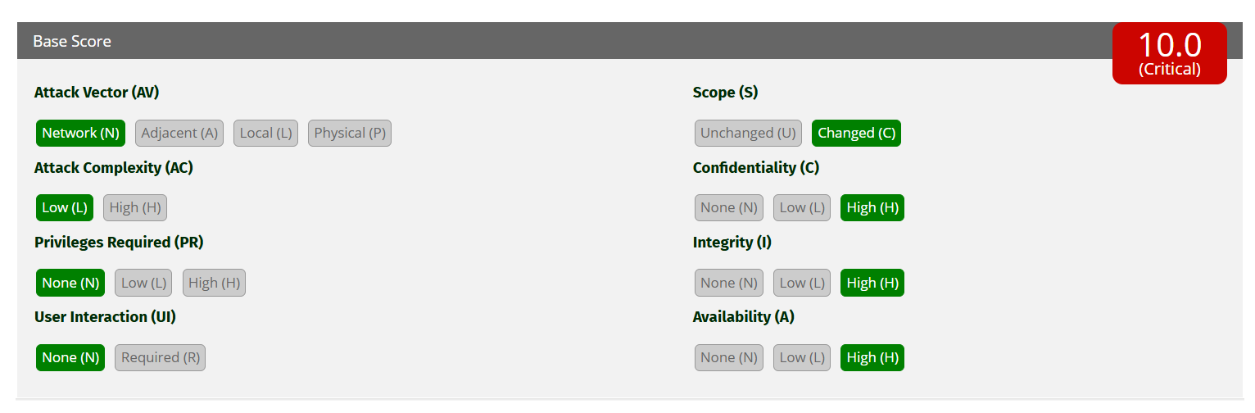

* **Affected IPs:**194.110.x.x
* **Affected Port:**N/A
* **CVE-ID:**N/A
* **Technical Impact:**The presence of an unsupported operating system like Windows 7 introduces a significant security risk to the environment. Since the OS no longer receives security updates or patches, it is highly susceptible to exploitation through known vulnerabilities. Attackers can leverage unpatched flaws to gain unauthorized access, execute malicious code, or escalate privileges, compromising the entire system. Additionally, this creates a potential entry point for lateral movement within the network, putting other systems at risk. Overall, the unsupported OS increases the likelihood of data theft, ransomware attacks, and operational disruptions.
* **Mitigation:**

Upgrade to a supported service pack or operating system

* **Reference:**

<https://www.tenable.com/plugins/nessus/108797>

* **POC:**



1. **Vulnerability Name: BlueKeep Vulnerability (Critical)**

* **Description:**The remote host is affected by a remote code execution vulnerability in Remote Desktop Protocol (RDP). An unauthenticated, remote attacker can exploit this, via a series of specially crafted requests, to execute arbitrary code.
* **CVSS:**CVSS:3.1/AV:N/AC:L/PR:N/UI:N/S:U/C:H/I:H/A:H

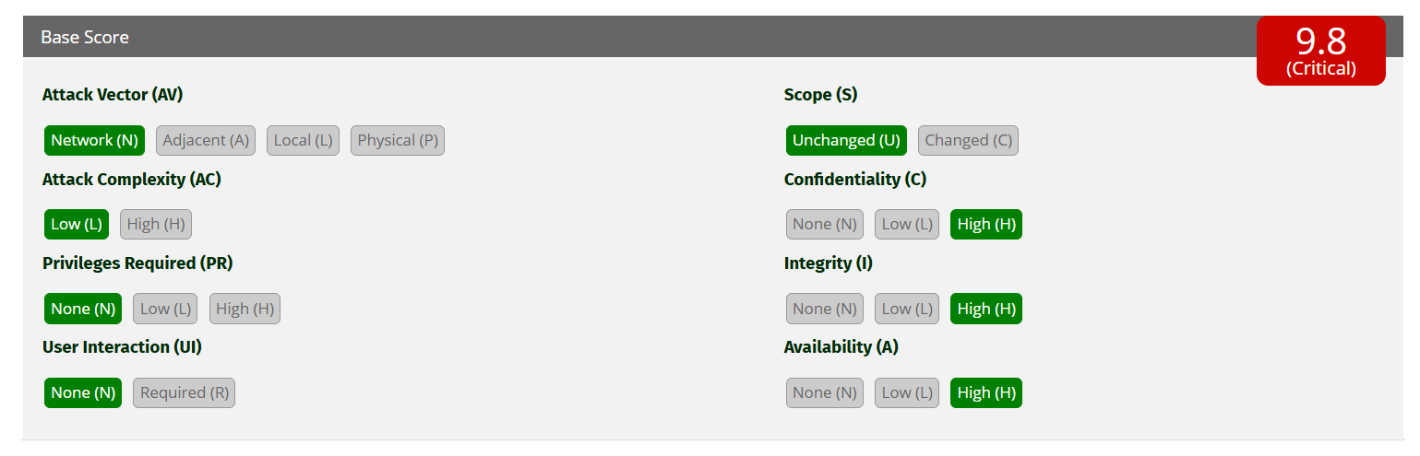

* **Affected IPs:**187.251.x.x
* **Affected Port:**3389 (RDP)
* **CVE-ID:**CVE-2019-0708
* **Technical Impact:**Attackers could execute arbitrary code and gain remote access.
* **Mitigation:**Patch the system and restrict RDP access.
* **Reference:**

<https://www.tenable.com/plugins/nessus/125313>

<http://www.nessus.org/u?577af692>

<http://www.nessus.org/u?8e4e0b74>

* **POC:**

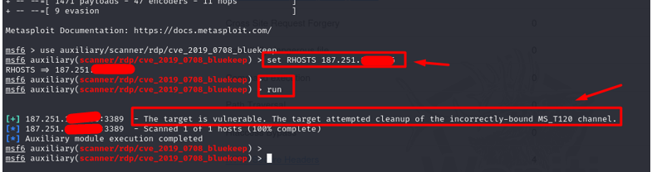

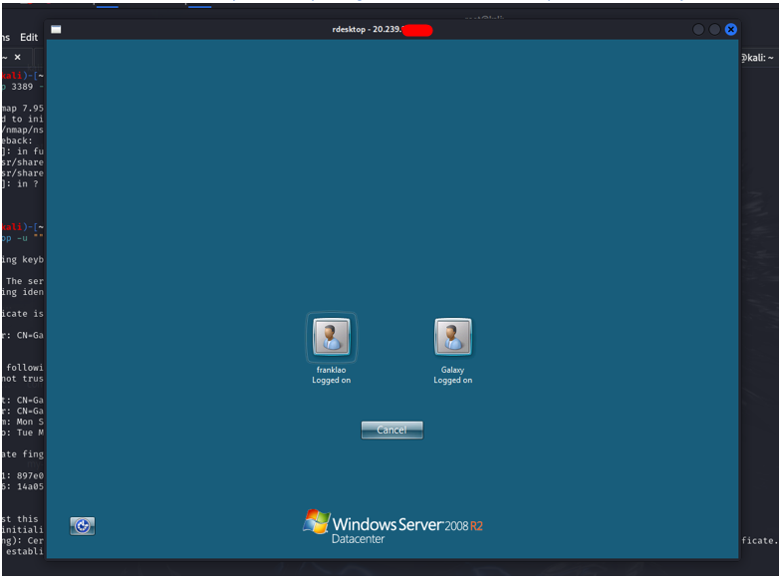

1. **Vulnerability Name: Default Credentials**

* **Description:**attacker was able to log in to telnet using default credentials. These credentials are publicly known and can allow an attacker to gain privileged access to the device.
* **CVSS: N/A**
* **Affected IPs:**2.74. x.x, 207.148.x.x
* **Affected Port:** 23/telnet, 21/ftp
* **CVE-ID: N/A**
* **Technical Impact:**

Attackers can gain unauthorized access to the system using publicly known default credentials. This allows them to execute commands, modify configurations, and potentially escalate privileges. If exploited, attackers can install backdoors, steal sensitive data, or use the compromised device to launch further attacks within the network.

* **Mitigation:**

**- Change Default Credentials:** Immediately update default usernames and passwords to strong, unique credentials.

**- Disable Unused Services:** If Telnet is not required, disable it and use more secure alternatives like SSH.

**- Restrict Access:** Limit access to Telnet and FTP by allowing only trusted IP addresses through firewall rules.

**- Enable Multi-Factor Authentication (MFA):** If supported, enable MFA to add an additional security layer.

**- Monitor and Log Access:** Regularly monitor authentication logs for unauthorized login attempts and enforce account lockout policies.

* **Reference:**

<https://www.tenable.com/plugins/nessus/72236>

* **POC**

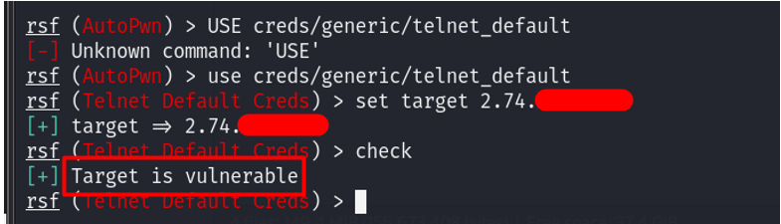

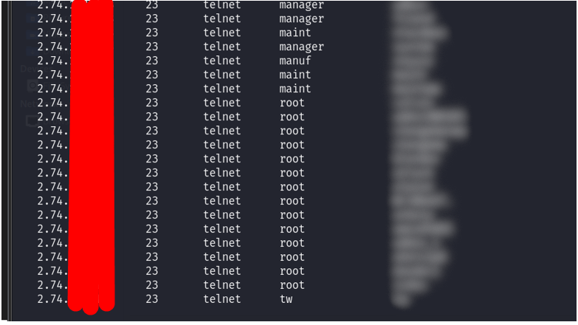

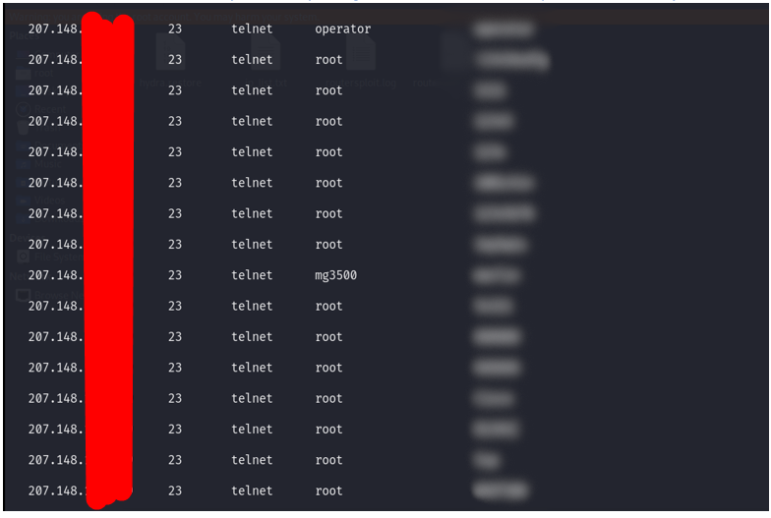

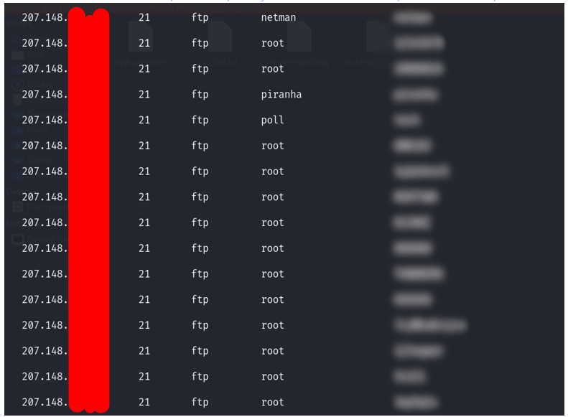

1. **Vulnerability Name: PHP Unsupported Version Detection**

* **Description:**According to its version, the installation of PHP on the remote host is no longer supported.  
  Lack of support implies that no new security patches for the product will be released by the vendor. As a result, it is likely to contain security vulnerabilities.
* **CVSS:**CVSS:3.1/AV:N/AC:L/PR:N/UI:N/S:U/C:L/I:L/A:L

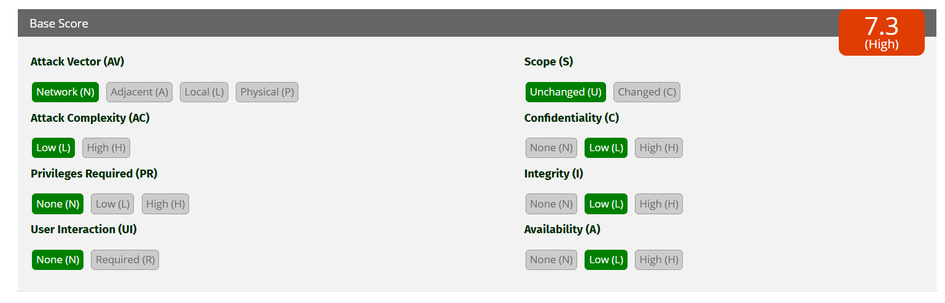

* **Affected IPs:** [219.94.](https://localhost:8834/)x.x
* **Affected Port:**443 / tcp / www
* **CVE-ID:**[CVE-2010-4645](https://www.tenable.com/cve/CVE-2010-4645),[CVE-2024-4577](https://www.cybersecurity-help.cz/vdb/SB2024060501), [CVE-2024-5458](https://www.cybersecurity-help.cz/vdb/SB2024060501), [CVE-2024-2408](https://www.cybersecurity-help.cz/vdb/SB2024060501)
* **Technical Impact:**Running an outdated and unsupported version of PHP exposes the server to unpatched vulnerabilities, making it an attractive target for attackers. This can result in remote code execution, privilege escalation, or information disclosure. An unsupported PHP version also risks being exploited for website defacement, malware injection, or data exfiltration. Beyond security, such outdated software decreases reliability and compatibility with modern tools, potentially causing service disruptions and hindering business operations.
* **Mitigation:**Upgrade to a version of PHP that is currently supported.
* **Reference:**

<https://www.tenable.com/plugins/nessus/58987%20>

<https://www.tenable.com/plugins/was/98230>

<https://www.exploit-db.com/exploits/29290>

* **POC:**

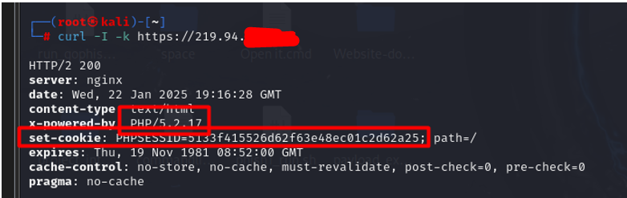

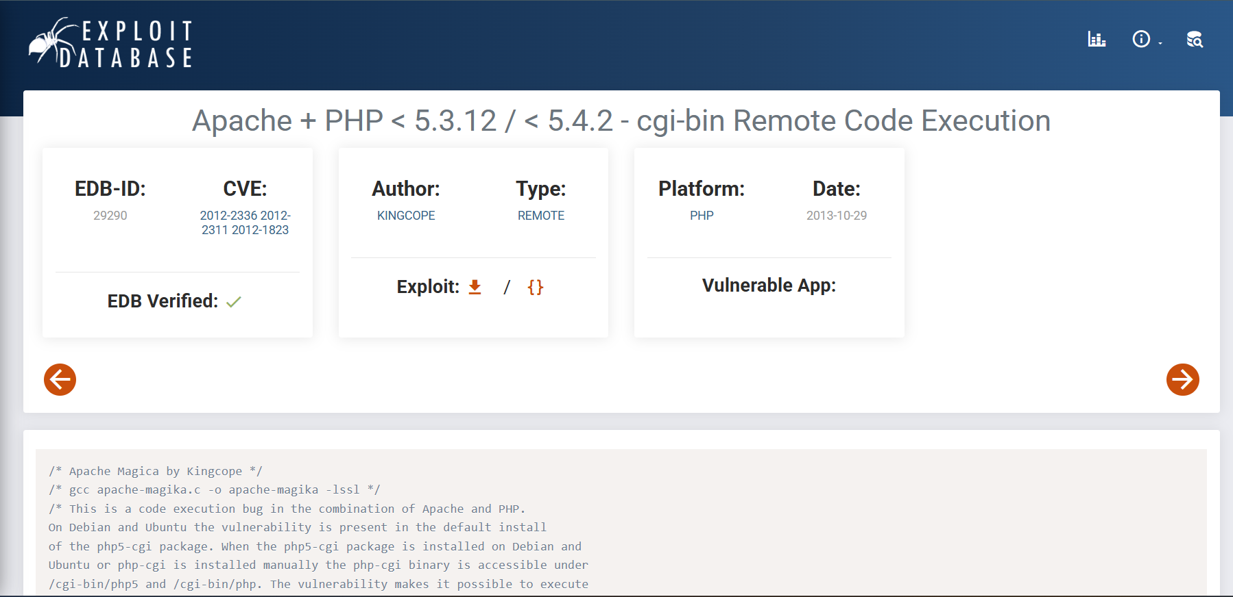

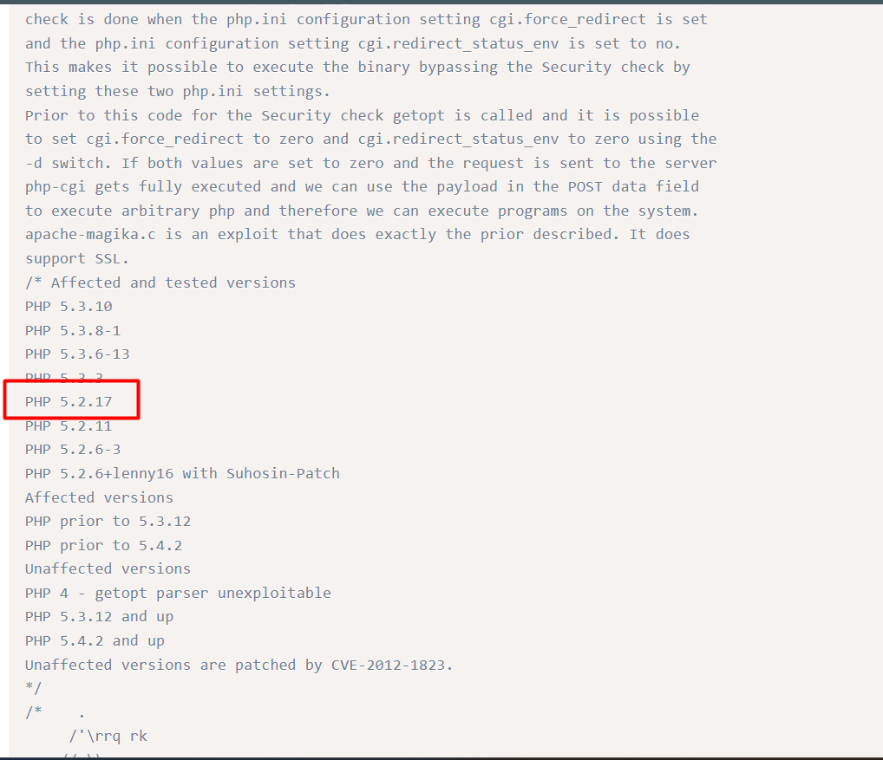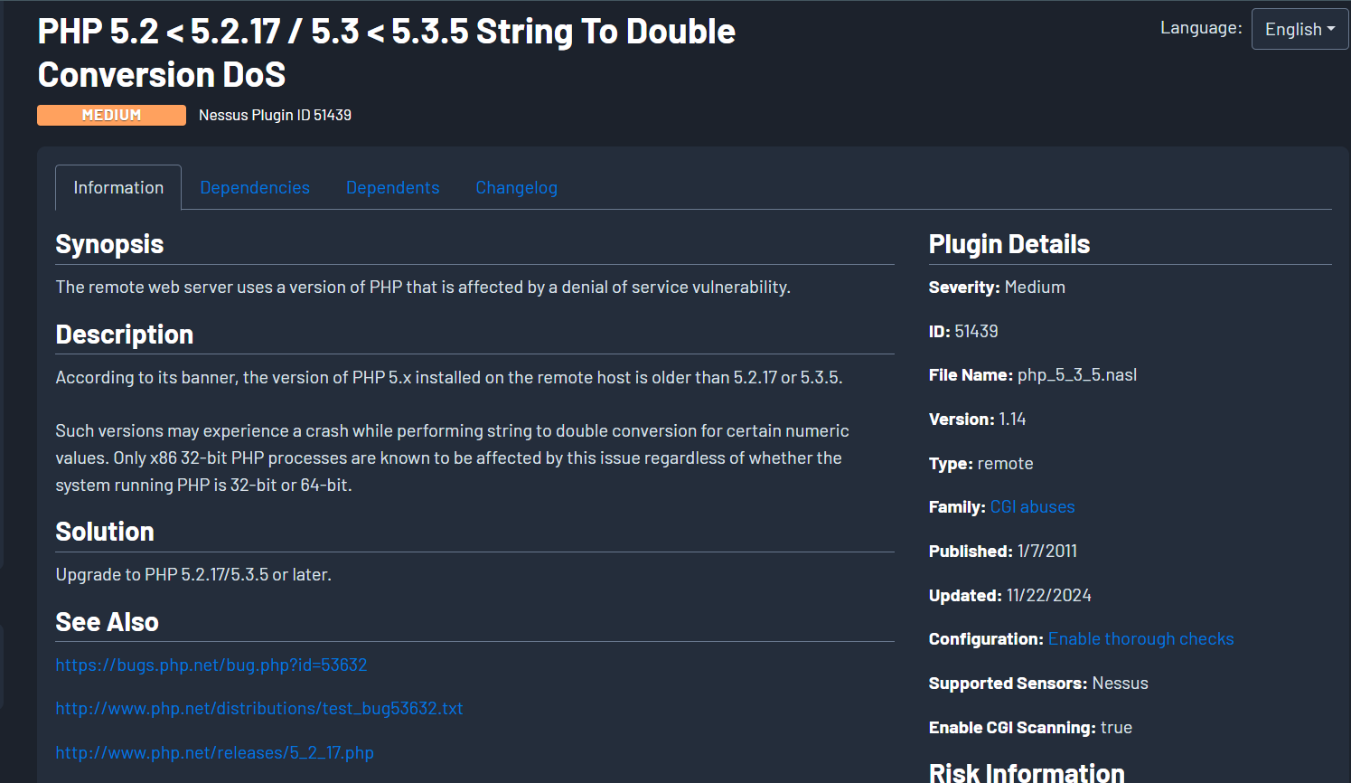

1. **Vulnerability Name: Unsupported Web Server Detection (Critical)**

* **Description:**According to its version, the remote web server is obsolete and no longer maintained by its vendor or provider.  
  Lack of support implies that no new security patches for the product will be released by the vendor. As a result, it may contain security vulnerabilities.
* **CVSS:**CVSS:3.0/AV:N/AC:L/PR:N/UI:N/S:C/C:H/I:H/A:H

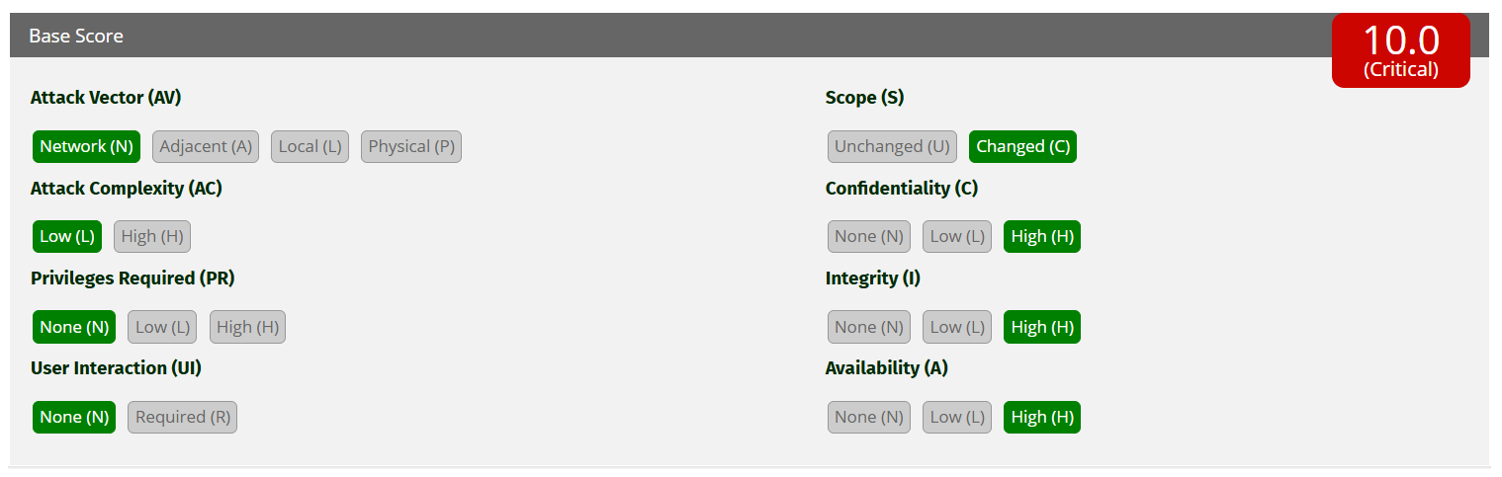

* **Affected IPs:**20.239.x.x
* **Affected Port:**80 / tcp / www
* **CVE-ID:** CVE-2015-1635, CVE-2017-7269, CVE-2019-0941
* **Technical Impact:**An unsupported web server presents critical security risks as it lacks regular updates and patches, leaving it vulnerable to exploitation. Attackers can exploit these vulnerabilities to gain control of the server, execute malicious code, or exfiltrate sensitive data. The lack of maintenance increases the likelihood of a complete server compromise, enabling attackers to use it as a launchpad for further attacks. This not only jeopardizes data confidentiality but also risks reputational damage and regulatory non-compliance.
* **Mitigation:** Remove the web server if it is no longer needed. Otherwise, upgrade to a supported version if possible or switch to another server.
* **Reference:**

<https://www.tenable.com/plugins/nessus/34460>

* **POC:**

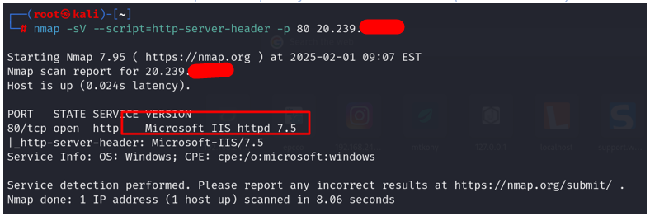

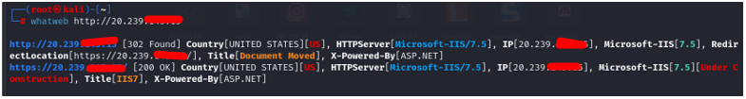

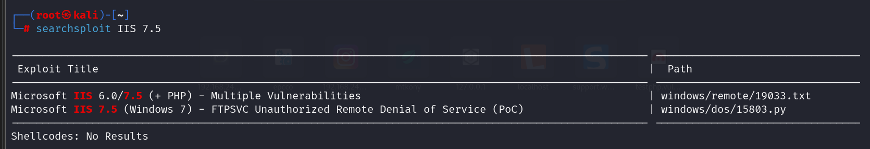

1. **Vulnerability Name: Geutebruck G-Cam/EFD-2250 RCE**

* **Description:** Multiple camera devices by UDP Technology, Geutebrück and other vendors are vulnerable to a stack-based buffer overflow condition in the action parameter, which may allow an attacker to remotely execute arbitrary code.
* **CVSS:**CVSS:3.0/AV:N/AC:L/PR:H/UI:N/S:U/C:H/I:H/A:H

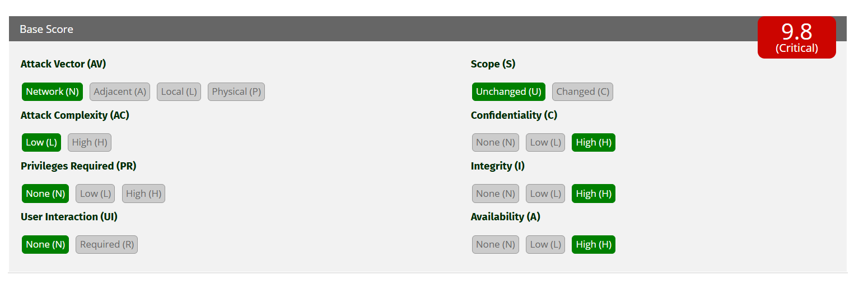

* **Affected IPs:**185.216. x.x
* **Affected Port:**80/http
* **CVE-ID:** CVE-2021-33549
* **Technical Impact:**

Remote code execution allows attackers to execute arbitrary commands on the device, potentially gaining full control over the camera system. Unauthorized access may enable attackers to bypass authentication and manipulate camera feeds. A compromised device can be used as a pivot point for further attacks on the internal network. Exploiting this vulnerability may also cause service disruption, leading to denial of service.

* **Mitigation:**

-Apply Firmware Update: Update the device firmware to the latest version provided by Geutebruck or UDP Technology to patch the vulnerability.

-Restrict Network Access: Limit access to the camera’s web interface (port 80) by allowing only trusted IP addresses through firewall rules.

-Disable Unused Services: If remote management over HTTP is not required, disable it and use HTTPS with authentication.

-Enable Strong Authentication: Ensure that default credentials are changed and strong passwords are enforced.

-Monitor Logs & Traffic: Regularly inspect device logs for suspicious activity and use an intrusion detection system (IDS) to detect exploit attempts.

* **Reference:**

<https://www.tenable.com/cve/CVE-2021-33549>

* **POC:**

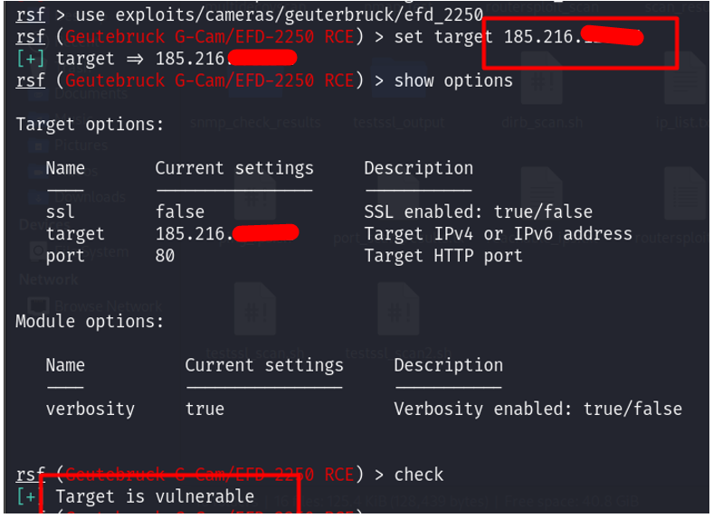

High

1. **Vulnerability Name: MTA Open Mail Relaying Allowed (done)**

* **Description:**the remote SMTP server allows mail relaying.  
  This issue allows any spammer to use your mail server to send their mail to the world, thus flooding your network bandwidth and possibly getting your mail server blacklisted.
* **CVSS:**CVSS:3.1/AV:N/AC:L/PR:N/UI:N/S:U/C:H/I:N/A:N

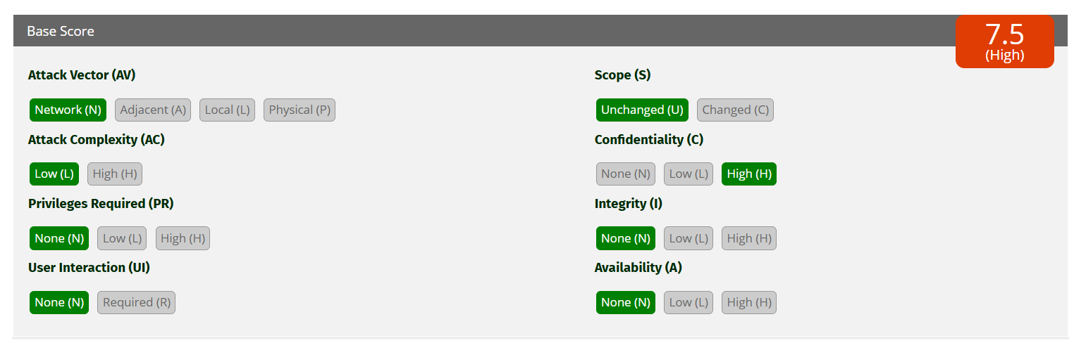

* **Affected IPs:**207.148. x.x
* **Affected** Port: 2525 / tcp / smtp
* **CVE-ID:**CVE-1999-0512, CVE-2002-1278, CVE-2003-0285
* **Technical Impact:**Allowing open mail relaying on an SMTP server poses a serious security threat by enabling spammers to misuse the server for sending bulk unsolicited emails. This can lead to the server being blacklisted, resulting in the disruption of legitimate email services and damaging the organization’s reputation. Additionally, the increased bandwidth consumption from spam emails can degrade network performance and create operational inefficiencies. This vulnerability exposes the organization to financial and reputational risks.
* **Mitigation:**Reconfigure your SMTP server so that it cannot be used as an indiscriminate SMTP relay. Make sure that the server uses appropriate access controls to limit the extent to which relaying is possible.
* **Reference:**

<https://en.wikipedia.org/wiki/Email_spam>

<https://www.tenable.com/plugins/nessus/10262>

<https://www.tenable.com/plugins/nessus/118017>

* **POC:**

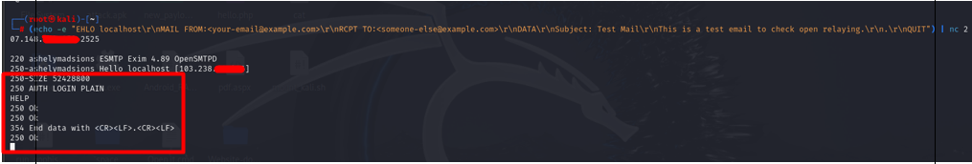

1. **Vulnerability Name:  SNMP Agent Default Community Name (public)**

* **Description:**It is possible to obtain the default community name of the remote SNMP server.  
  An attacker may use this information to gain more knowledge about the remote host, or to change the configuration of the remote system (if the default community allows such modifications).
* **CVSS:**CVSS:3.1/AV:N/AC:L/PR:N/UI:N/S:U/C:H/I:N/A:N

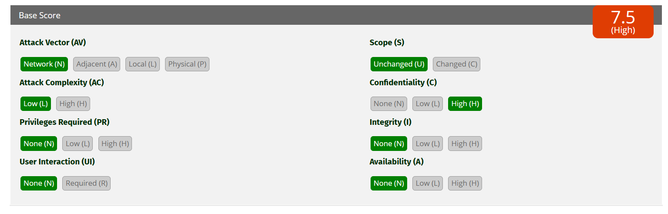

* **Affected IPs:**[102.212.x.x](https://localhost:8834/),[124.117.x.x](https://localhost:8834/)
* **Affected Port:**161/udp/snmp
* **CVE-ID:**[CVE-1999-0517](http://web.nvd.nist.gov/view/vuln/detail?vulnId=CVE-1999-0517), [CVE-2008-4309](https://www.tenable.com/cve/CVE-2008-4309)
* **Technical Impact:**The use of a default SNMP community string, such as “public,” poses a severe risk to the system. Attackers can leverage this to gather detailed information about the remote host, facilitating reconnaissance and further attacks. If the SNMP configuration allows write access, attackers may modify critical settings, leading to potential service disruptions or system misuse. This vulnerability also exposes the network to Denial-of-Service (DoS) attacks and increases the risk of sensitive information leakage, compromising the overall security of the environment.
* **Mitigation:** Disable the SNMP service on the remote host if you do not use it.  
  Either filter incoming UDP packets going to this port, or change the default community string.
* **Reference:**

<https://www.tenable.com/plugins/nessus/41028>

<https://www.tenable.com/plugins/nessus/76474>

[**https://www.tenable.com/plugins/nessus/76474**](https://www.tenable.com/plugins/nessus/76474)

[**http://www.nessus.org/u?8b551b5c**](http://www.nessus.org/u?8b551b5c)

* **POC:**

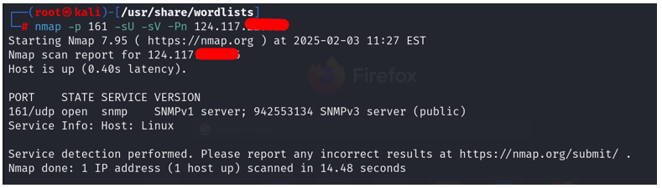

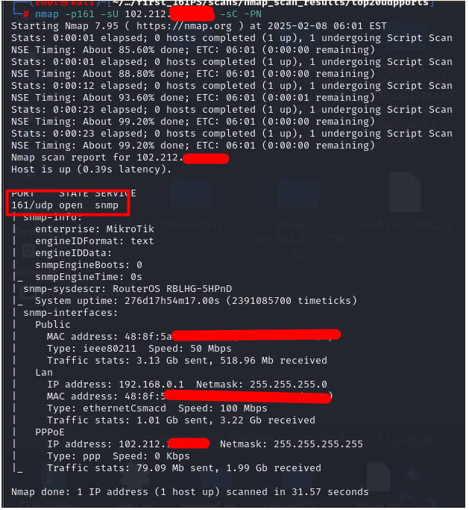

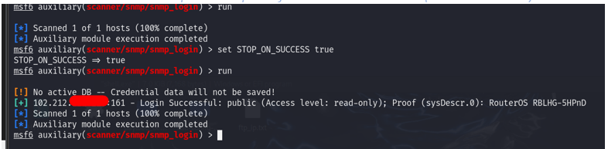

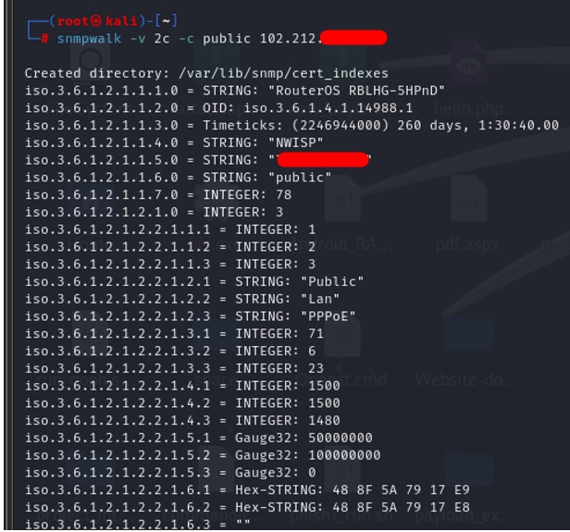

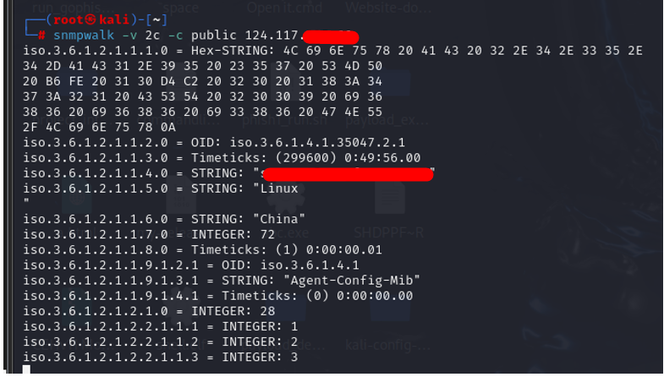

1. **Vulnerability Name: Terminal Services Encryption Level is Medium or Low**

* **Description:**The remote Terminal Services service is not configured to use strong cryptography.

Using weak cryptography with this service may allow an attacker to eavesdrop on the communications more easily and obtain screenshots and/or keystrokes.

* **CVSS:**CVSS:3.1/AV:N/AC:L/PR:N/UI:N/S:U/C:H/I:L/A:N

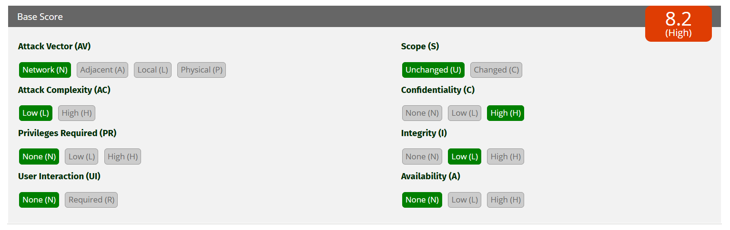

* **Affected IPs:**187.251. x.x
* **Affected Port:**3389 (RDP)
* **CVE-ID:**N/A
* **Technical Impact:**Unauthorized access to the system could allow attackers to gain full control.
* **Mitigation:**Change RDP encryption level to one of : 1. High 2. FIPS Compliant
* **Reference:**

[**https://www.tenable.com/plugins/nessus/57690**](https://www.tenable.com/plugins/nessus/57690)

* **POC:**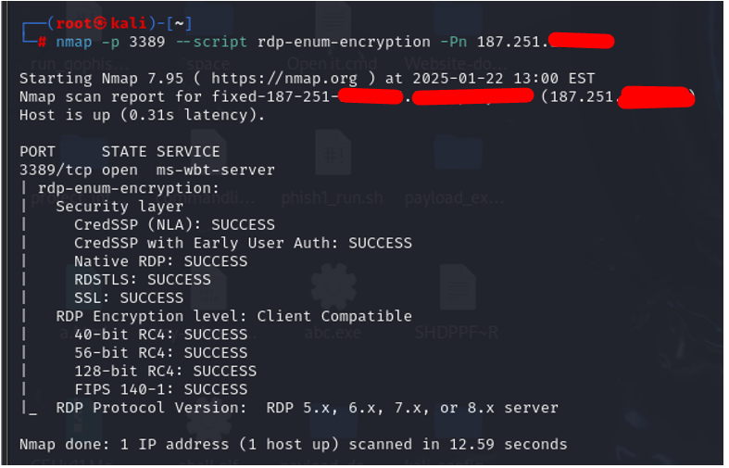

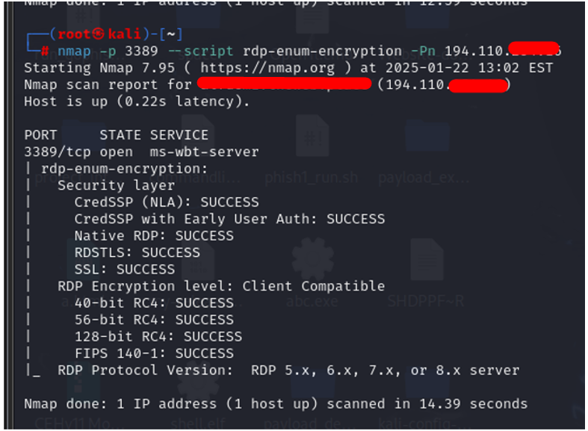

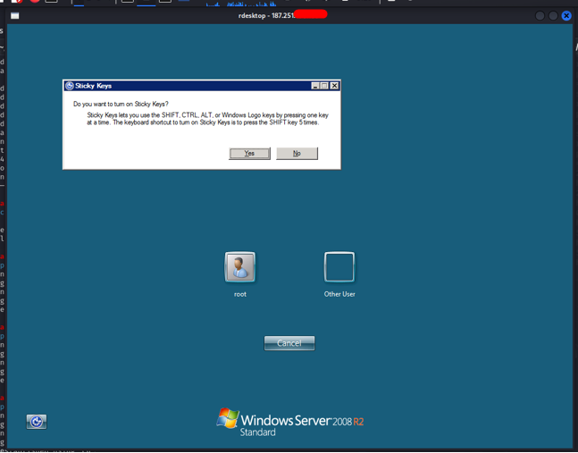

1. **Vulnerability Name: Anonymous FTP Login (Read & Write Access)**

* **Description:**The FTP service allows login without requiring authentication, enabling unauthorized access to the server.
* **CVSS:**CVSS:3.1/AV:N/AC:L/PR:N/UI:N/S:U/C:H/I:L/A:N

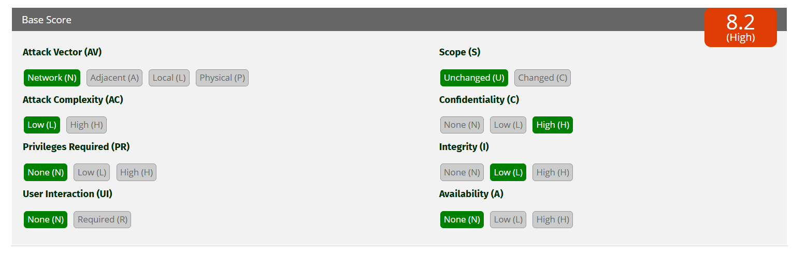

* **Affected IPs:**67.20.x.x, 207.148.x.x
* **Affected Port:**21 (FTP)
* **CVE-ID:**N/A
* **Technical Impact:**Data exposure and server integrity risk.
* **Mitigation:**Disable anonymous login and implement strong authentication.
* **Reference:**

<https://www.tenable.com/plugins/nessus/10079>

* **POC:**

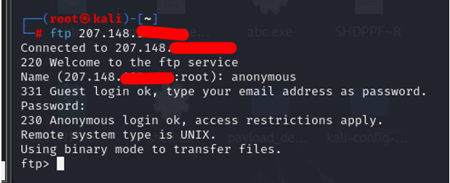

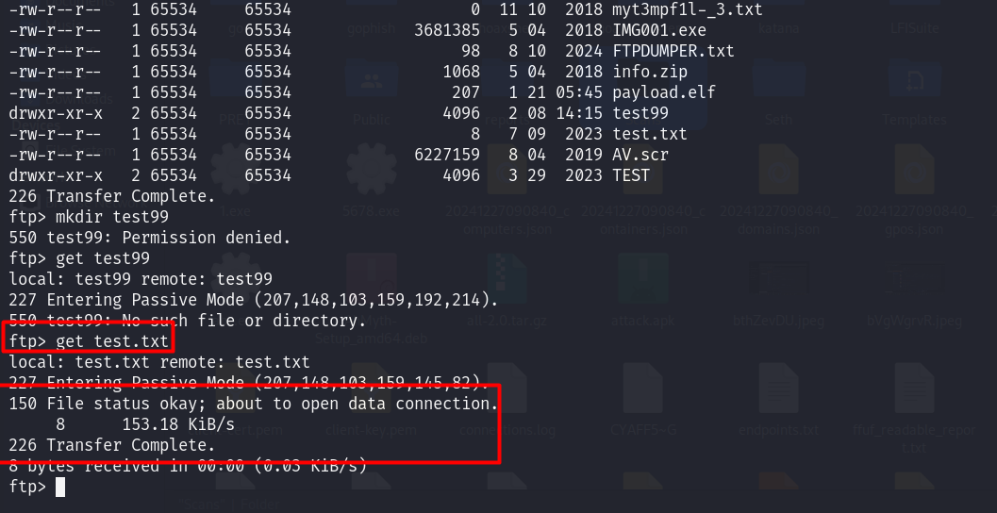

1. **Vulnerability Name: SNMP Misconfiguration (High)**

* **Description:**The SNMP service is accessible, potentially without authentication or with weak community strings.
* **CVSS:**CVSS:3.1/AV:N/AC:L/PR:N/UI:N/S:U/C:H/I:N/A:L

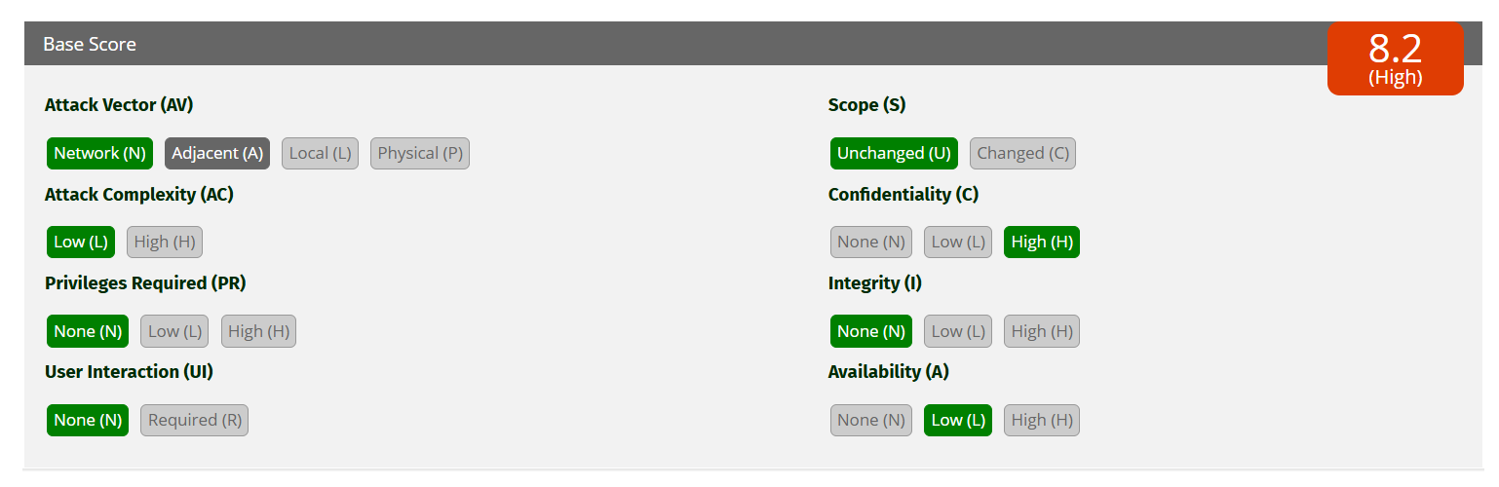

* **Affected IPs:**124.117.x.x, 103.23.x.x,
* **Affected Port:**161 (SNMP)
* **CVE-ID: N/A**
* **Technical Impact:**Information leakage and reconnaissance for attackers.
* **Mitigation:**Secure SNMP configuration and restrict access.
* **Reference:**

<https://www.tenable.com/plugins/nessus/41028>

**POC:**

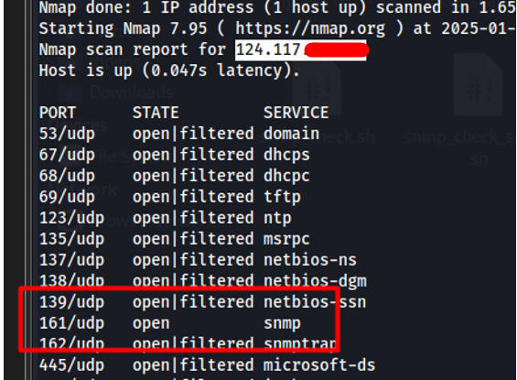

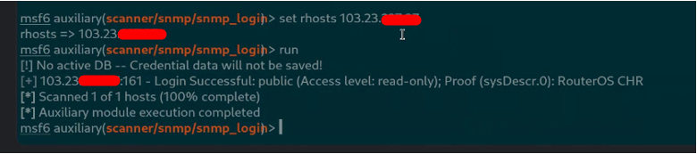

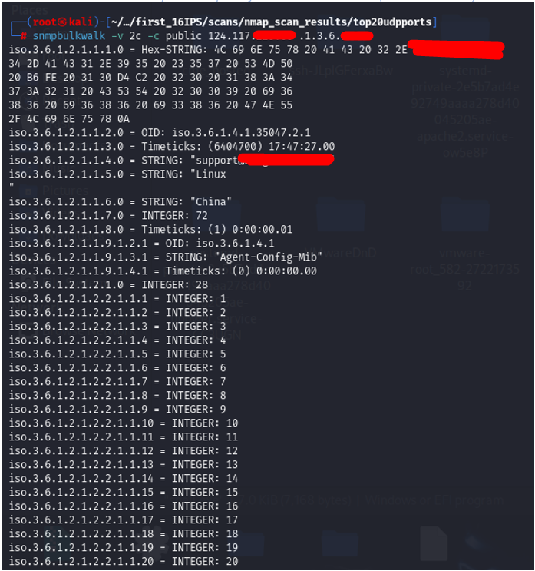

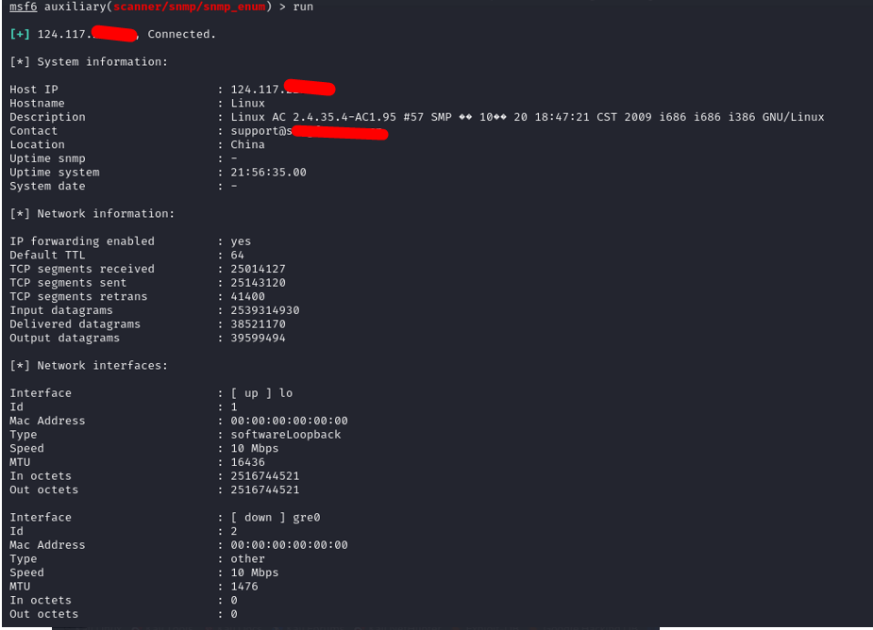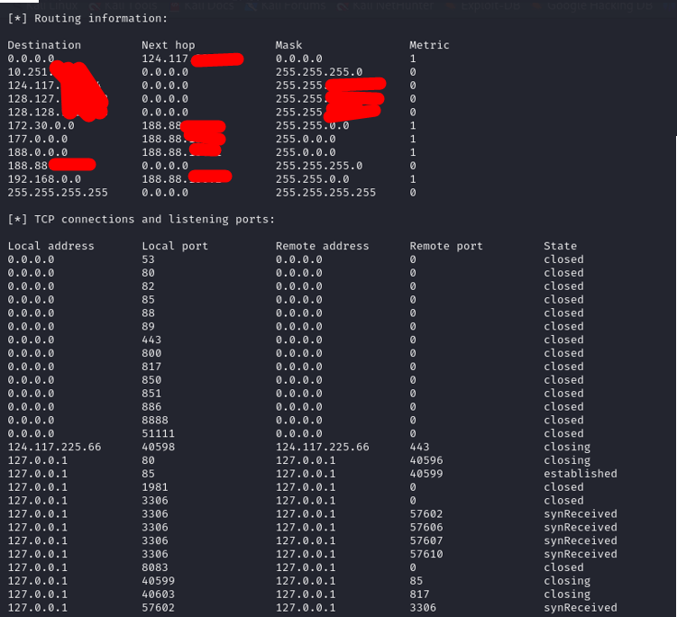

1. **Vulnerability Name: Web Server Directory Traversal Arbitrary File Access (High)**

* **Description:**It appears possible to read arbitrary files on the remote host outside the web server's document directory using a specially crafted URL. An unauthenticated attacker may be able to exploit this issue to access sensitive information to aide in subsequent attacks.  
  Note that this plugin is not limited to testing for known vulnerabilities in a specific set of web servers. Instead, it attempts a variety of generic directory traversal attacks and considers a product to be vulnerable simply if it finds evidence of the contents of '/etc/passwd' or a Windows 'win.ini' file in the response. It may, in fact, uncover 'new' issues, that have yet to be reported to the product's vendor.
* **CVSS:**CVSS:3.1/AV:N/AC:L/PR:N/UI:N/S:U/C:H/I:N/A:N

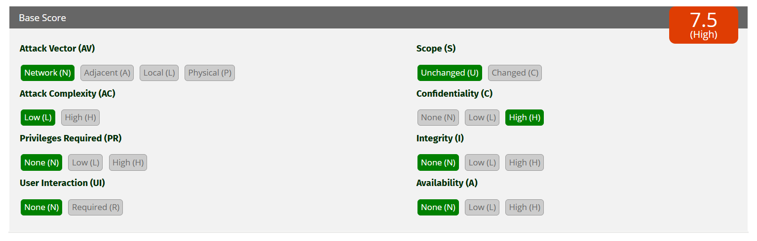

* **Affected IPs:**207.148.x.x
* **Affected Port:**82 / tcp / www
* **CVE-ID:**
* **Technical Impact:**A directory traversal vulnerability allows unauthorized access to sensitive files outside the web server’s document root. Attackers can exploit this to obtain configuration files, credentials, or other critical information, which can then be used to launch subsequent attacks. This compromises the confidentiality and integrity of data stored on the server and can aid in privilege escalation or unauthorized code execution. Such vulnerabilities significantly weaken the security posture of the organization.
* **Mitigation:**Contact the vendor for an update, use a different product, or disable the service altogether.
* **Reference:**

<https://www.tenable.com/plugins/nessus/10297>

* **POC:**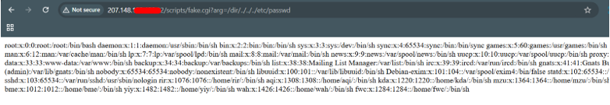
* 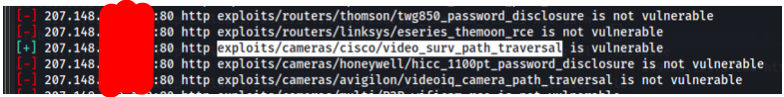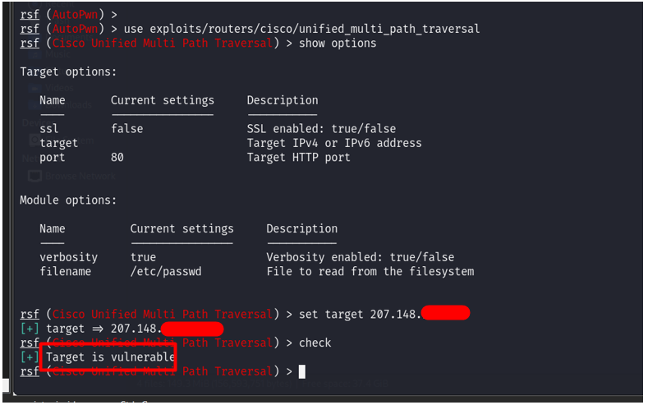

Medium

1. **Vulnerability Name: Terminal Services Doesn't Use Network Level Authentication (NLA) Only**

* **Description:**The remote Terminal Services is not configured to use Network Level Authentication (NLA) only. NLA uses the Credential Security Support Provider (CredSSP) protocol to perform strong server authentication either through TLS/SSL or Kerberos mechanisms, which protect against man-in-the-middle attacks. In addition to improving authentication, NLA also helps protect the remote computer from malicious users and software by completing user authentication before a full RDP connection is established.
* **CVSS:** CVSS:3.1/AV:N/AC:L/PR:N/UI:N/S:U/C:L/I:L/A:N

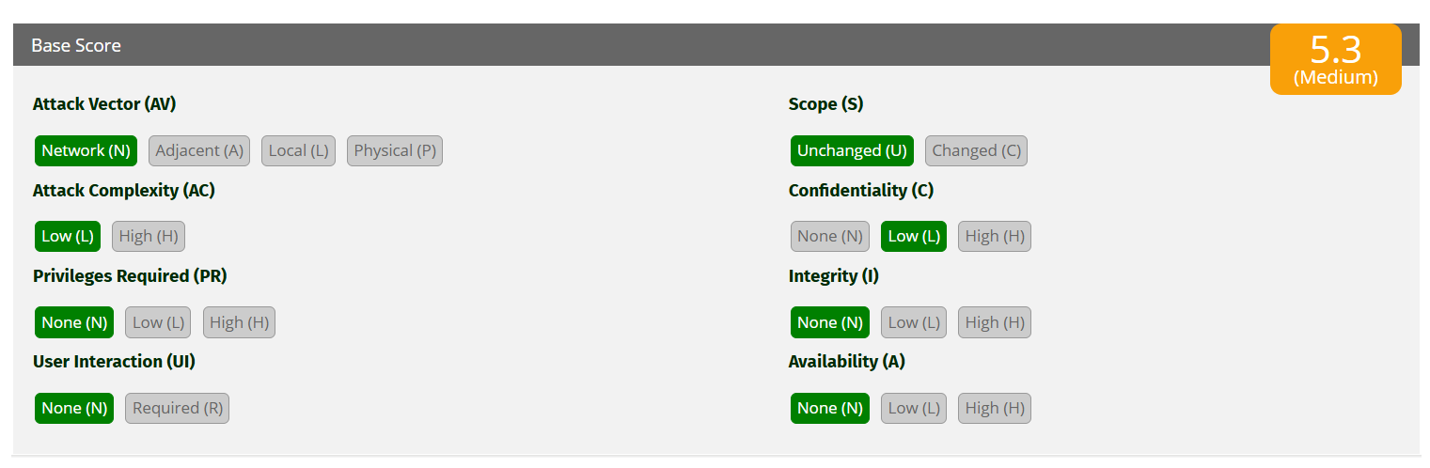

* **Affected IPs:**194.110.x.x, [20.239.x.x](https://localhost:8834/)
* **Affected Port:**3389 (RDP)
* **CVE-ID:**N/A
* **Technical Impact:**

Unauthorized access to the system could allow attackers to gain full control.

* **Mitigation:**

1. Enforce **NLA** for RDP sessions.

2. Use strong, unique credentials for RDP accounts.

3. Restrict access to RDP services through firewalls (e.g., only allow specific IPs).

4. Disable RDP on systems unless strictly necessary.

5. Upgrade unsupported systems (e.g., Windows 7) to a supported version of Windows.

6. Monitor RDP access for unusual activity (e.g., multiple failed login attempts).

* **Reference:**

[**https://www.tenable.com/plugins/nessus/58453**](https://www.tenable.com/plugins/nessus/58453)

[**https://docs.microsoft.com/en-us/previous-versions/windows/it-pro/windows-server-2008-R2-and-2008/cc732713(v=ws.11)**](https://docs.microsoft.com/en-us/previous-versions/windows/it-pro/windows-server-2008-R2-and-2008/cc732713(v=ws.11))

* **POC:**
* 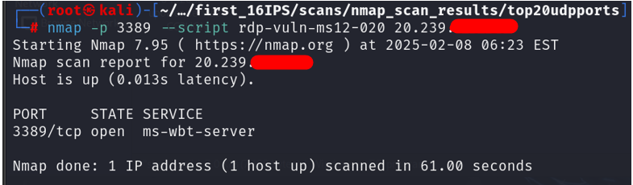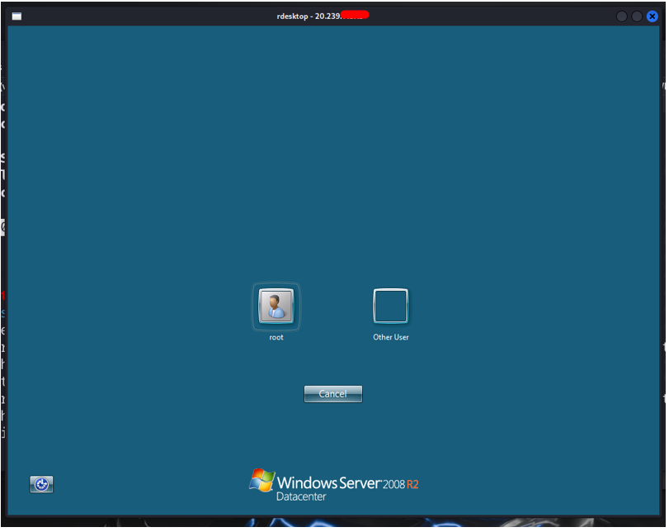



1. **Vulnerability Name: Remote Desktop Protocol Server Man-in-the-Middle Weakness (High)**

* **Description:**The remote version of the Remote Desktop Protocol Server (Terminal Service) is vulnerable to a man-in-the-middle (MiTM) attack. The RDP client makes no effort to validate the identity of the server when setting up encryption. An attacker with the ability to intercept traffic from the RDP server can establish encryption with the client and server without being detected. A MiTM attack of this nature would allow the attacker to obtain any sensitive information transmitted, including authentication credentials.  
  This flaw exists because the RDP server stores a publicly known hard-coded RSA private key. Any attacker in a privileged network location can use the key for this attack.
* **CVSS: CVSS:3.0/AV:N/AC:L/PR:N/UI:N/S:U/C:L/I:L/A:N**

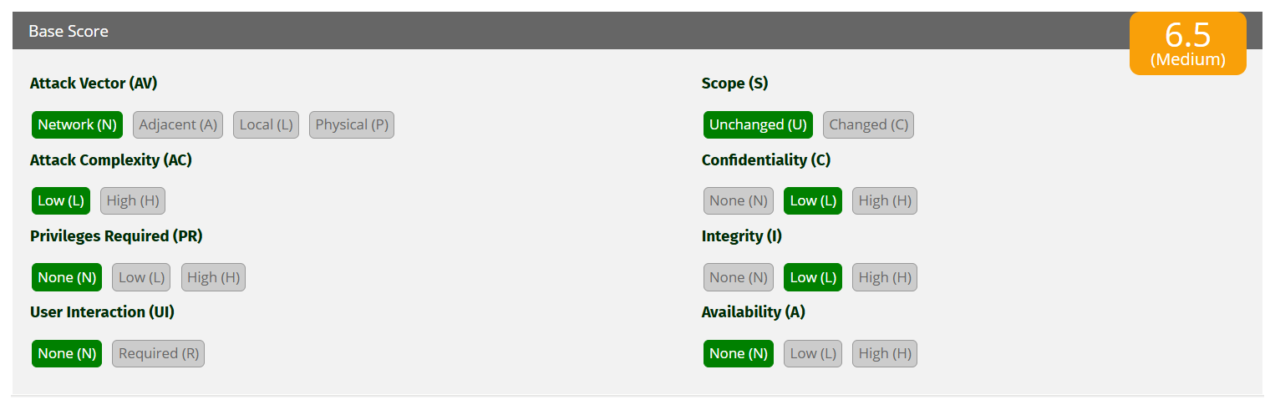

* **Affected IPs:**[**20.239.x.x**](https://localhost:8834/)
* **Affected Port: 3389 / tcp / msrdp**
* **CVE-ID:**[**CVE-2005-1794**](http://web.nvd.nist.gov/view/vuln/detail?vulnId=CVE-2005-1794)
* **Technical Impact:**The vulnerability in the Remote Desktop Protocol (RDP) server makes it susceptible to man-in-the-middle (MiTM) attacks. Since the client does not validate the server's identity during encryption setup, attackers can intercept sensitive information such as credentials or session data. This weakness compromises the confidentiality and integrity of data transmitted over the RDP session and facilitates unauthorized access to the network. Exploiting this vulnerability can lead to further attacks, including data breaches and privilege escalation.
* **Mitigation:**

- Force the use of SSL as a transport layer for this service if supported, or/and  
- On Microsoft Windows operating systems, select the 'Allow connections only from computers running Remote Desktop with Network Level Authentication' setting if it is available.

* **Reference:**

[**https://nvd.nist.gov/vuln/detail/cve-2005-1794**](https://nvd.nist.gov/vuln/detail/cve-2005-1794)

[**https://www.tenable.com/plugins/nessus/18405**](https://www.tenable.com/plugins/nessus/18405)

[**http://www.nessus.org/u?8033da0d**](http://www.nessus.org/u?8033da0d)

* **POC:**

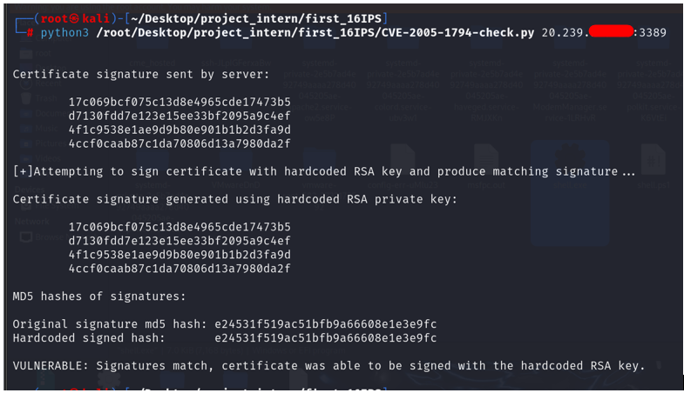

1. **Vulnerability Name: Unencrypted Telnet Server**

* **Description:**The remote host is running a Telnet server over an unencrypted channel.  
  Using Telnet over an unencrypted channel is not recommended as logins, passwords, and commands are transferred in cleartext. This allows a remote, man-in-the-middle attacker to eavesdrop on a Telnet session to obtain credentials or other sensitive information and to modify traffic exchanged between a client and server.  
  SSH is preferred over Telnet since it protects credentials from eavesdropping and can tunnel additional data streams such as an X11 session.
* **CVSS: CVSS:3.0/AV:N/AC:L/PR:N/UI:N/S:U/C:L/I:L/A:N**

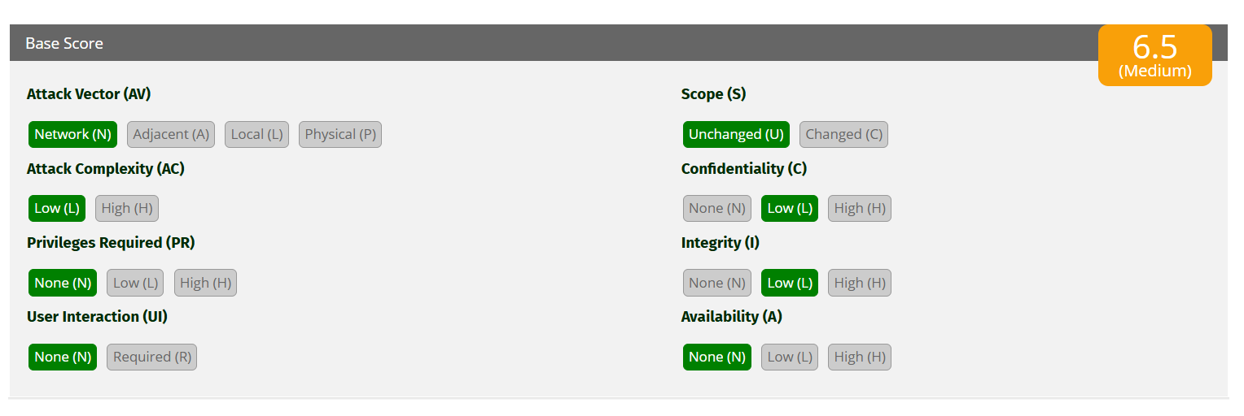

* **Affected IPs:**[142.132.x.x](https://localhost:8834/), [207.148.x.x](https://localhost:8834/) , [184.74.x.x](https://localhost:8834/), [105.235.x.x](https://localhost:8834/)
* **Affected Port:**23/tcp/telnet,2323/tcp/telnet
* **CVE-ID: N/A**
* **Technical Impact:**Running an unencrypted Telnet server poses a high-security risk as it transmits sensitive data, including credentials, in plaintext. This allows attackers to intercept and eavesdrop on the communication, potentially leading to credential theft or session hijacking. Additionally, attackers can perform man-in-the-middle attacks or modify transmitted data, compromising the integrity of the system. The use of outdated and insecure protocols like Telnet significantly weakens the overall security posture and increases exposure to cyber threats.
* **Mitigation:**Disable the Telnet service and use SSH instead.
* **Reference:**

[**https://www.tenable.com/plugins/nessus/42263**](https://www.tenable.com/plugins/nessus/42263)

* **POC:**

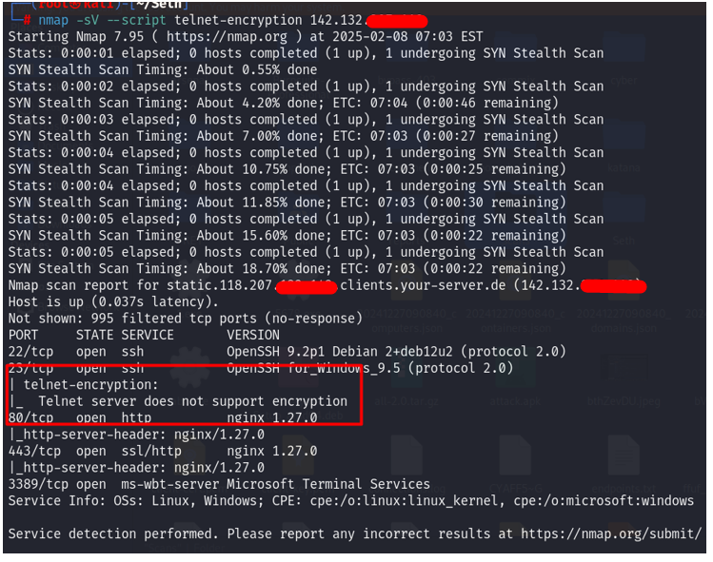

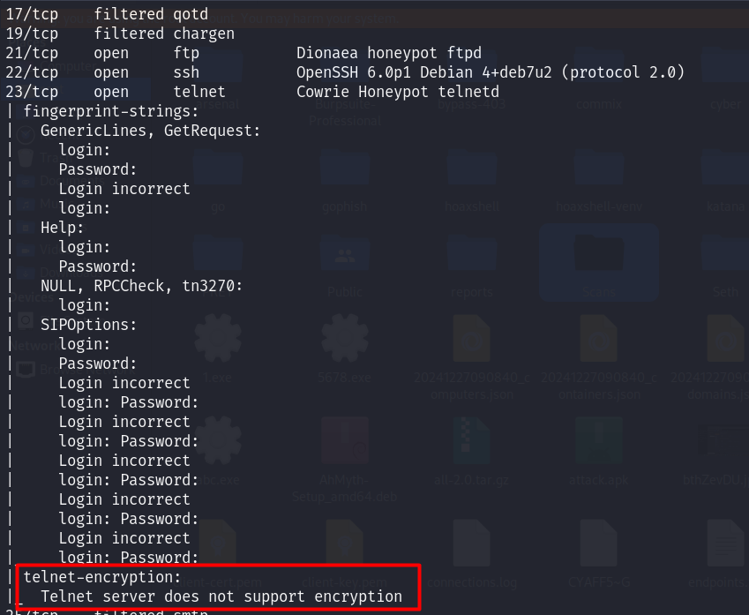

1. **Vulnerability Name: Presence of an Open DNS Port (53/UDP) (Medium)**

* **Description:**The presence of an open DNS port (53/UDP) exposes the system to potential DNS-related vulnerabilities. Misconfigured or unsecured DNS services can allow attackers to exploit the system for amplification attacks (e.g., DNS amplification in DDoS), cache poisoning, or reconnaissance activities. Open recursive DNS servers are especially vulnerable as they can be abused for reflection/amplification attacks.
* **CVSS:**CVSS 3.1 (5.3): AV:N/AC:L/PR:N/UI:N/S:U/C:N/I:N/A:L
* **Affected IPs:**67.20.x.x
* **Affected Port:**53/UDP
* **CVE-ID: N/A**
* **Technical Impact:** DNS amplification can significantly contribute to Distributed Denial-of-Service (DDoS) attacks, potentially overwhelming network resources. ,An open recursive DNS resolver can allow attackers to use the system as a proxy for malicious activities. , Unauthenticated access to the DNS service may allow attackers to gather sensitive information about internal networks.
* **Mitigation:**
* Restrict Access: Configure the DNS server to restrict queries to trusted IP addresses or internal networks only.Block external access to port 53/UDP unless required for legitimate services.
* Disable Recursion: Disable DNS recursion if the server is not intended to be a recursive resolver.
* Rate Limiting: Apply rate-limiting on the DNS server to mitigate the risk of amplification attacks.
* Firewall Rules: Use firewall rules to block unauthorized external access to port 53/UDP.
* Monitor and Update: Monitor DNS logs for unusual activity and apply security patches for known vulnerabilities in the DNS software.
* **Reference:**

[**https://www.csk.gov.in/csksa/csksa_03.html**](https://www.csk.gov.in/csksa/csksa_03.html)

[**https://technet.microsoft.com/en-us/library/cc787602.aspx**](https://technet.microsoft.com/en-us/library/cc787602.aspx)

[**https://www.cisa.gov/news-events/alerts/2013/03/29/dns-amplification-attacks**](https://www.cisa.gov/news-events/alerts/2013/03/29/dns-amplification-attacks)

[**https://tools.cisco.com/security/center/resources/dns_best_practices**](https://tools.cisco.com/security/center/resources/dns_best_practices)

* **POC:**

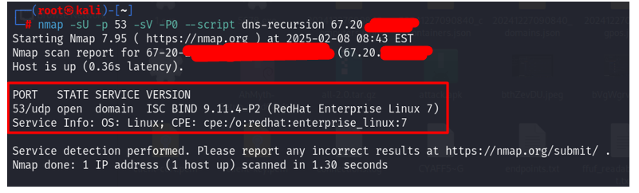

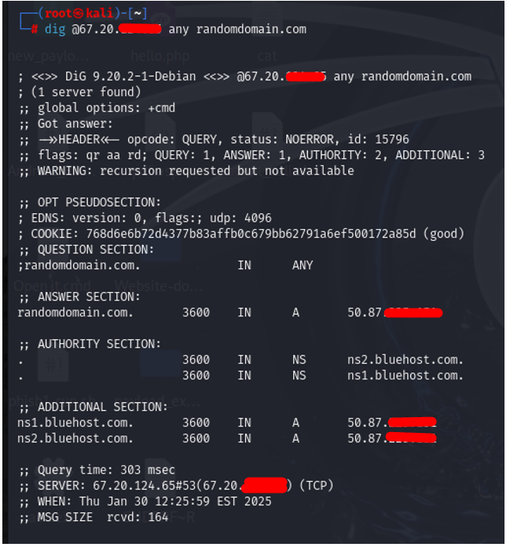

**this indicates that recursion is enabled, and it is an open recursive DNS resolver. This makes the server vulnerable to abuse, such as DNS amplification attacks.**

1. **Vulnerability Name: LUCKY13 (Medium)**

* **Description:**The LUCKY13 vulnerability exploits a weakness in the TLS/DTLS implementation of cipher block chaining (CBC) mode. This side-channel attack uses timing discrepancies to infer plaintext information, such as sensitive data from encrypted communications. The vulnerability affects TLS implementations that do not properly process padding bytes during decryption.
* **CVSS:**CVSS 3.1: AV:N/AC:H/PR:N/UI:N/S:U/C:L/I:N/A:N
* **Affected IPs:**106.225.x.x
* **Affected Port:**443 (HTTPS), 8443 (alternative HTTPS)
* **CVE-ID: CVE-2013-0169**
* **Technical Impact:**The attacker can potentially decrypt sensitive data such as session cookies, login credentials, or confidential information transmitted over TLS/DTLS., The attack relies on precise timing measurements, making it feasible only under certain conditions (e.g., close proximity to the target)., Could compromise the confidentiality of data encrypted with vulnerable TLS/DTLS implementations.
* **Mitigation:**Update Software: Upgrade to the latest version of TLS/DTLS libraries (e.g., OpenSSL, GnuTLS) that have patched the LUCKY13 vulnerability by implementing proper padding checks and countermeasures., Disable CBC Ciphers: Configure your server to prioritize or exclusively use secure alternatives like AES-GCM or ChaCha20-Poly1305, which are not vulnerable to LUCKY13., Use TLS 1.2 or Higher: Ensure that your system supports and enforces the use of TLS 1.2 or higher, as it addresses vulnerabilities present in earlier versions., Enable Strict Timing Measures: If using CBC ciphers, ensure that implementations follow constant-time cryptographic operations to mitigate timing side-channels.
* **Reference:**[**https://nvd.nist.gov/vuln/detail/CVE-2** **013-0169**](https://nvd.nist.gov/vuln/detail/CVE-2013-0169)
* 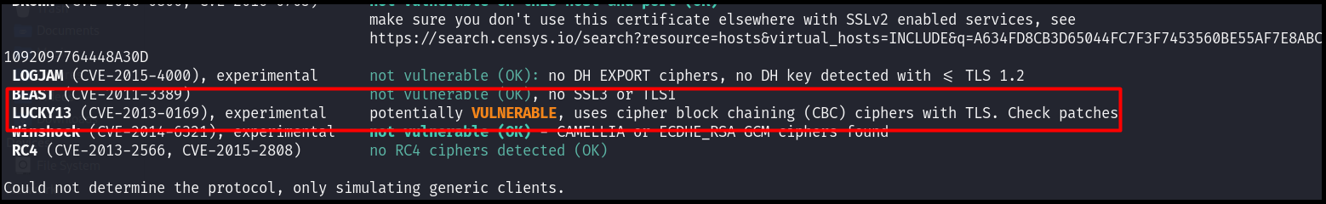**POC:**

1. **Vulnerability Name: SSL Medium Strength Cipher Suites Supported (SWEET32) (Medium) (done)**

* **Description:**

The remote host supports the use of SSL ciphers that offer medium strength encryption. Nessus regards medium strength as any encryption that uses key lengths at least 64 bits and less than 112 bits, or else that uses the 3DES encryption suite.  
  
Note that it is considerably easier to circumvent medium strength encryption if the attacker is on the same physical network.

* **CVSS:**CVSS:3.1/AV:N/AC:H/PR:N/UI:N/S:U/C:M/I:M/A:N

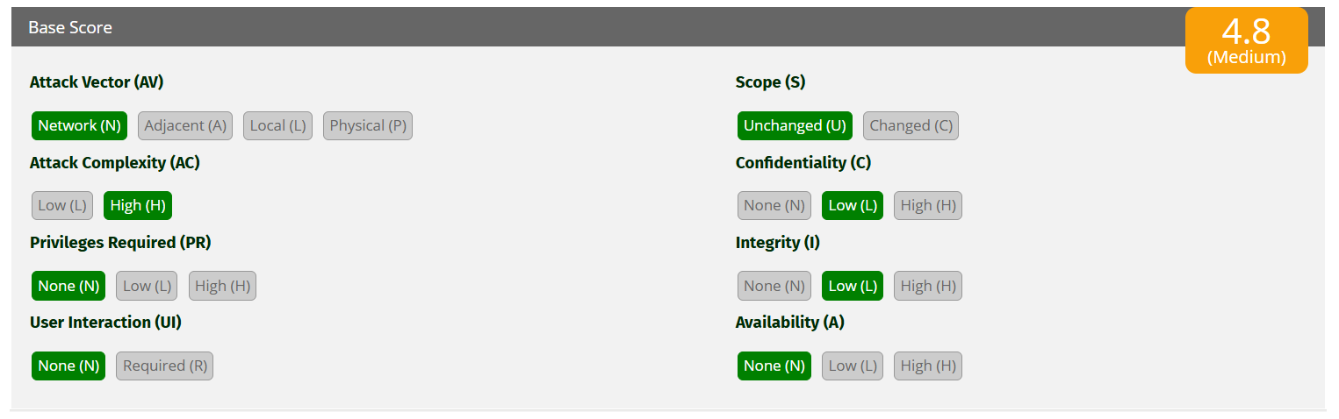

* **Affected IPs:**[185.146.x.x](https://localhost:8834/), [20.239.x.x](https://localhost:8834/),[142.132.x.x](https://localhost:8834/), [184.74.x.x](https://localhost:8834/), [124.117.x.x](https://localhost:8834/)
* **Affected Port:**465/tcp/smtp,3389/tcp/msrdp,1112/tcp/www,44333/tcp/www
* **CVE-ID:**[**CVE-2016-2183**](http://web.nvd.nist.gov/view/vuln/detail?vulnId=CVE-2016-2183)
* **Technical Impact:**The use of medium-strength SSL ciphers, such as 3DES, increases susceptibility to cryptographic attacks like SWEET32. An attacker on the same network can exploit these weaknesses to intercept or manipulate encrypted data, undermining its confidentiality and integrity. While medium-strength ciphers are less vulnerable than weak ones, they still fall short of modern security standards. This vulnerability not only compromises secure communications but also impacts compliance with industry regulations, such as PCI DSS.
* **Mitigation:** Reconfigure the affected application if possible to avoid use of medium strength ciphers.
* **Reference:**
  + <https://www.openssl.org/blog/blog/2016/08/24/sweet32/>
  + <https://sweet32.info>
* **POC:**

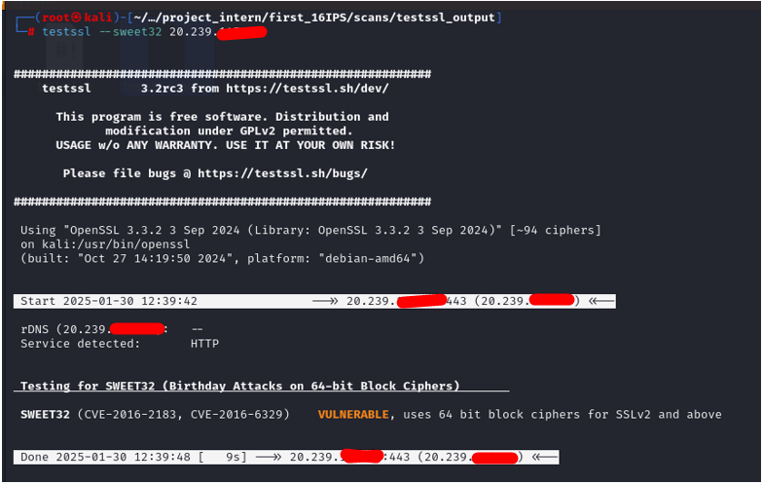

Low

Info

1. **Vulnerability Name: OpenSSH Password Authentication Enabled and Capture OpenSSH Version**

* **Description:**The OpenSSH service is configured to allow password-based authentication. This can be exploited using brute-force attacks if weak or default passwords are used. Additionally, the OpenSSH version disclosed may be outdated, exposing the system to known vulnerabilities.
* **CVSS: N/A**
* **Affected IPs:**103.56.x.x
* **Affected Port:**22 (ssh)
* **CVE-ID:  N/A**
* **Technical Impact:**Unauthorized system access if weak or default passwords are used.

Exploitation of OpenSSH vulnerabilities may lead to data theft, system compromise, or further lateral movement in the network.

* **Mitigation:**1.Disable password-based authentication and enforce public key authentication in /etc/ssh/sshd_config: PasswordAuthentication no

2. Regularly update OpenSSH to the latest version to address known vulnerabilities.

3. Use a firewall to restrict SSH access to trusted IP addresses.

4. Implement monitoring tools like fail2ban to detect and block brute-force attempts.

* **Reference:**

**https://www.tenable.com/plugins/nessus/149334**

* **POC:**

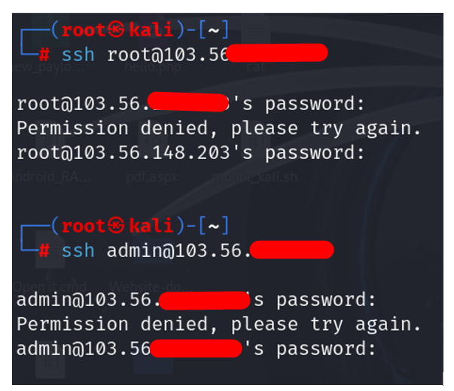

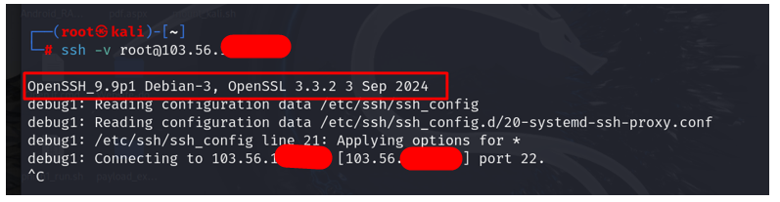

1. **Conclusion**

The comprehensive Vulnerability Assessment and Penetration Testing (VAPT) conducted on the network infrastructure identified a spectrum of security vulnerabilities ranging from critical to medium severity. Below is a detailed summary of the conclusions drawn from this assessment:

**Critical Vulnerabilities:**

- Unsupported Operating Systems: Specifically, Windows 7 was found on one of the systems, which is critically outdated, posing a high risk of exploitation due to lack of security patches.

- BlueKeep Vulnerability: This critical flaw in RDP allows for remote code execution, presenting an immediate threat to system integrity and confidentiality.

**High Severity Issues:**

- Default Credentials on Services: Systems using default credentials for Telnet and FTP were identified, making them prime targets for unauthorized access.

- RDP Misconfigurations: Lack of Network Level Authentication (NLA) and weak encryption settings on RDP services could lead to unauthorized control of systems.

- Web Server Vulnerabilities: An outdated web server and directory traversal vulnerabilities could expose sensitive data or allow server compromise.

**Medium Severity Risks:**

- Outdated Software: PHP installations and VNC viewers are no longer supported, increasing the likelihood of exploitation through known vulnerabilities.

- SNMP Misconfigurations: Default or weak community strings and accessible SNMP services could lead to information leakage or be used in DDoS reflection attacks.

- Encryption and Authentication Weaknesses: Issues like the LUCKY13 vulnerability in TLS/DTLS and medium strength SSL ciphers (SWEET32) compromise data confidentiality.

**Mitigation and Recommendations:**

- Immediate Patching: Critical vulnerabilities, particularly those related to unsupported OS and known exploits like BlueKeep, should be addressed immediately by patching or upgrading systems.

- Configuration Hardening: Services like RDP, SNMP, and Telnet need immediate reconfiguration to enforce strong authentication, change default credentials, and apply restrictive access controls.

- Software Updates: Upgrade all outdated software, including web servers, PHP, and VNC, to versions that are currently supported and secured.

- Network Security Enhancements: Implement firewalls, restrict service access, and ensure that only necessary services are exposed to the internet.

- Encryption Standards: Upgrade encryption protocols, disable weak cipher suites, and enforce the use of TLS 1.2 or higher where applicable.

- Monitoring and Policy Enforcement: Continuous monitoring for unusual network activities and strict adherence to security policies will help in identifying and mitigating threats early.

**General Observations:**

- The assessment was conducted under the constraints typical of a black-box approach, meaning some vulnerabilities might remain undetected due to the lack of internal system knowledge.

- The report's findings underscore the importance of regular security assessments, timely updates, and proactive security management to prevent exploitation.

**Operational Impact:**

- Implementing the suggested mitigations will require coordination across IT operations, potentially impacting service availability during upgrades or configuration changes.

- However, neglecting these vulnerabilities could lead to significant breaches, data loss, or service disruptions from external attacks.

In summary, this security assessment reveals significant areas of concern that require urgent attention. The organization should prioritize these findings, allocate resources for remediation, and consider enhancing their security practices to safeguard against future threats.